

VILNIUS UNIVERSITY
ŠIAULIAI ACADEMY
BACHELOR PROGRAMME SOFTWARE ENGINEERING

Computer networks laboratory work No. 3

Student : Hanna Asiadouskaya
Lecturer: dr. Nerijus Ramanauskas

Šiauliai, 2024
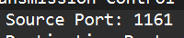
IP address: 192.168.1.102
TCP port number: 1161
- IP address of gaia.cs.umass.edu is 128.119.245.12
Port: 80
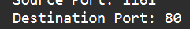
- IP address : 192.168.0.131
TCP port: 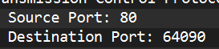
- Sequence number is 0. As the SYN flag is set to 1 it is a SYN segment
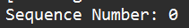
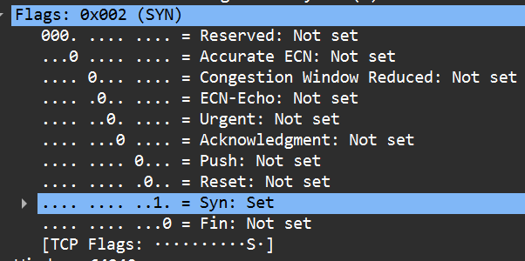
- Sequence number is 0 and the ACKnowledgment number is 1.
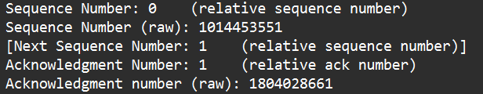

As in the segment there acknowledgment and syn flag this SYNACK segment.
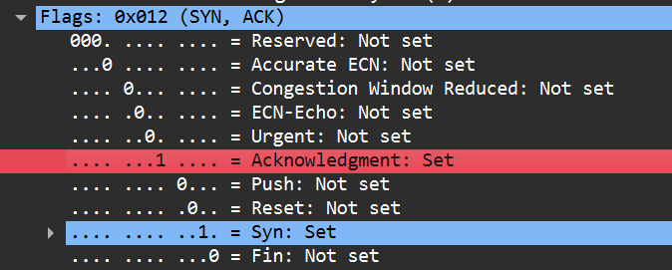
- The sequence number of this TCP segment is 1.
- 1st segment – 1
2nd segment – 737
3rd segment – 2195
4th segment – 3655
5th segment – 5115
6th segment – 6575
Packages mentioned like 24-29, will be named as S1-S6
Number | Time sent | ACK received | RTT
S1 | 4.42304 | 4.55257 | 0.12927
S2 | 4.42328 | 4.56283 | 0.13955
S3 | 4.42328 | 4.56283 | 0.13955
S4 | 4.42328 | 4.56283 | 0.13955
S5 | 4.42328 | 4.56283 | 0.13955
S6 | 4.42328 | 4.56283 | 0.13955

Estimated RTT = 0.875 * ERTT + 0.125 * SampleRTT
S1 Estimated RTT = S1 RTT = 0.12927
S2 Estimated RTT = 0.875 * S1 Estimated RTT + 0.125 * S2 RTT = 0.875 * 0.12927 + 0.125 * 0.13955
=0.130555
S3 Estimated RTT = 0.875 * S2 Estimated RTT + 0.125 * S3 RTT = 0.875 * 0.130555 + 0.125 * 0.13955
=0.13168

S4 Estimated RTT = 0.875 * S3 Estimated RTT + 0.125 * S4 RTT = 0.875 * 0.13168
+ 0.125 * 0.13955
=0.13266
S5 Estimated RTT = 0.875 * S4 Estimated RTT + 0.125 * S5 RTT = 0.875 * 0.13266 + 0.125 * 0.13955
=0.13352
S6 Estimated RTT = 0.875 * S5 Estimated RTT + 0.125 * S6 RTT = 0.875 * 0.13352 + 0.125 * 0.13955
=0.13427

- Length of the first segment – 733 bytes
Length of the each of the five TCP segments - 1460 bytes
- The minimum amount of buffer space - 5840 bytes. The sender is never throttled because we never reach full capacity of the window.
- There are no retransmitted segments in the trace file as its shows in Time-Sequence-Graph(Stevens) that all sequence numbers are increasing evenly.
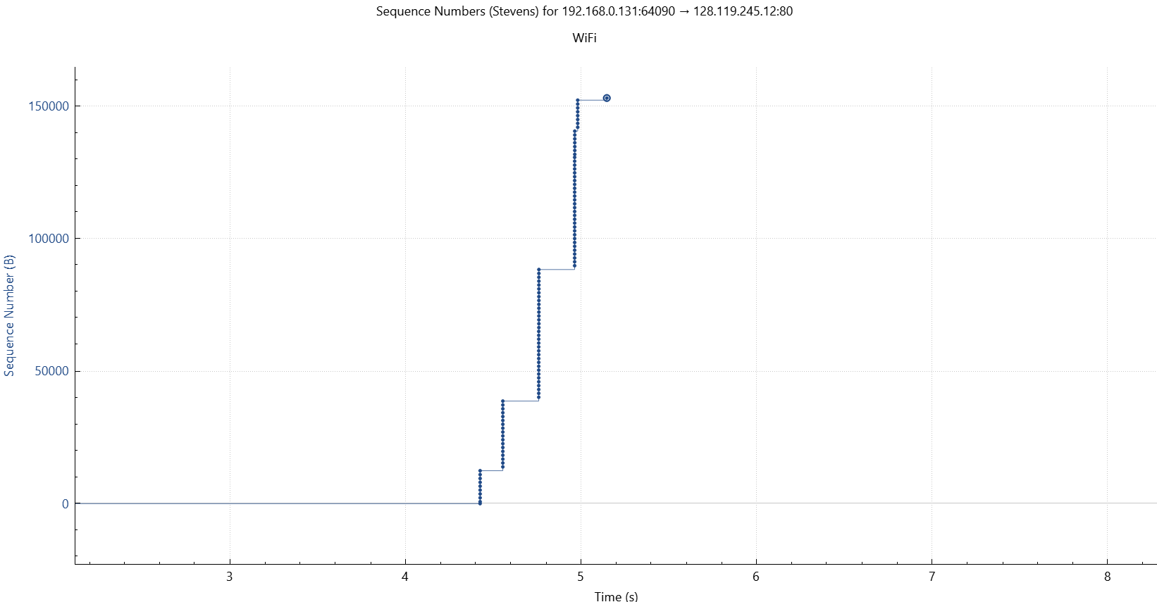
- The receiver acknowledges segments one by one. So, segment of number 26 will acknowledge data with 2920 bytes = default size of 1460*2(number of packet in payloads) bytes.
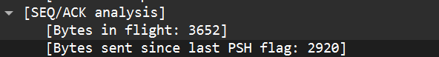

- To count the data transfer speed we need to know amount of data and amount of time the transfer took.
Amount of data can be calculated by using the value of the last acknowledge(153056) minus the first sequence number(1) divided by the time since first frame (5.145011) = 29.7482kb/s

- The TCP slowstart phase begins at above seq number 5000, (.15 seconds) and ends just before sequence number 10000. Congestion takes over at 10000.

- The slow start phase starts around zero and ends around 4.5 seconds according to the graph, after that the congestion takes over.

